MED D - SilverScript and Blue MedicareRx (NEJE) - Enrollment Related RM Tasks

Overview
RM Task Breakdown
Required Fields within the RM Task/Additional Information
Status Updates/ Resolution of RM Tasks
Alternate Format (i.e. Language/Print Change) Requests
Verbal Attestation
Contract and PBP ID
Address Change
State Field - next to Date of Birth
Task Category: Med D Enrollment - Demographic
Address Change
Out of Area
Name/DOB/MBI Change
Task Category: Med D Enrollment - Enrollment
Cancellation of Enrollment
Effective Date Change
Late Enrollment Penalty
Low Income Subsidy
Missing Pre-Enrollment Information
Opt Hold/ Group Attestation
TRC 127
SPAP
Enrollment Not Found
Enrollment/Eligibility Discrepancy
Task Category: Med D Enrollment - Disenrollment
Cancellation of Voluntary Disenrollment
Missing Information for Voluntary Disenrollment
Mistaken Disenrollment
Task Category: Med D Enrollment - Fulfillment
Fulfillment Request
Language/Print Change
Turn Around Times
Related Documents

Overview
MED D CCRs should use this document as a guide for enrollment related RM Tasks within PeopleSafe. For all other RM Tasks, refer to Resolution Manager RM Task Types Process.

For Health Plans, refer to CIF for direction. Do NOT use the RM Tasks within this document.

Reminder:
- Create all RM tasks from Participant Inquiry Tab, by clicking New (preferred method) instead of creating an RM task from the Medicare D Inquiry Tab.
- CCRs will almost always submit RM tasks using the Save and Clear button. The Save and Create Follow Up button should not be used, and the Save and Create Callback button should only be used when instructed to do so.

Notes:
- When speaking with the beneficiary state that you are submitting a request for their account to be researched, rather than I am creating a RM task.
- RM tasks that are submitted are NOT sent directly to Medicare to review.

Top of the Document

RM Task Breakdown
Below is a list of RM Tasks that are available in PeopleSafe for Med D Care Representatives (CCRs):

Med D Enrollment - Demographic
- Address Change
- Out of Area
- Name Change
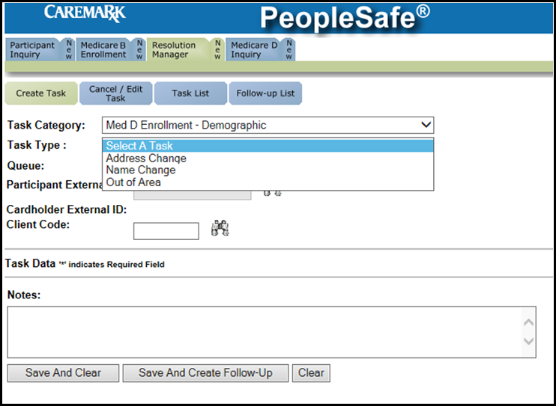
Figure A

Med D Enrollment - Enrollment
- Effective Date Change
- Enrollment Not Found
- Enrollment/Eligibility Discrepancy
- LIS - Low Income Subsidy
- Missing Pre-enrollment Information - RFI
- Opt Hold/Group Attestation
- SPAP - State Pharmaceutical Assistance Program

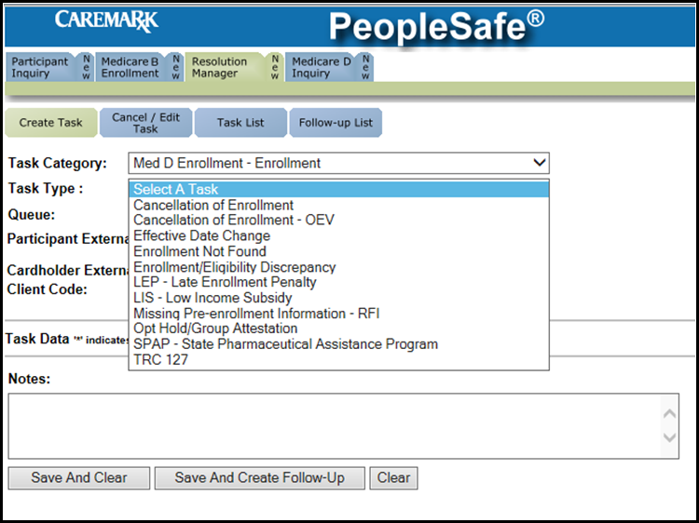
Figure B

Med D Enrollment - Disenrollment
- Cancellation of Voluntary Disenrollment
- Missing Information for Voluntary Disenrollment
- Mistaken Disenrollment

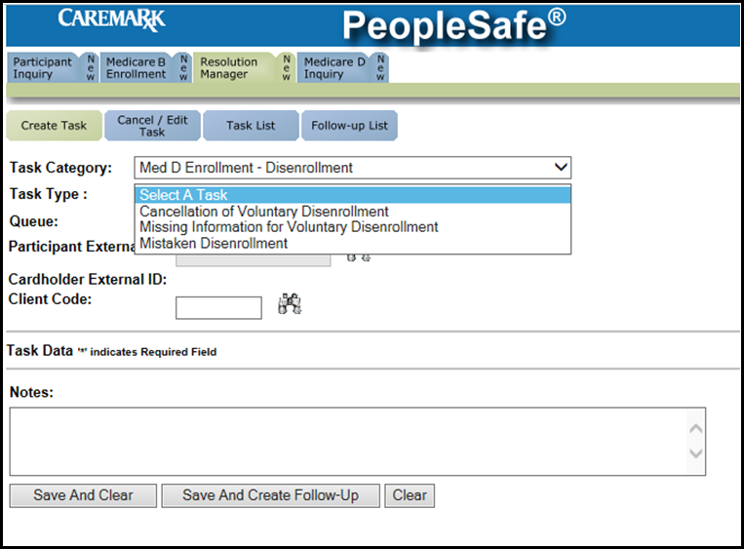
Figure C

Med D Enrollment - Fulfillment
- Fulfillment Request
- Language/Print Change

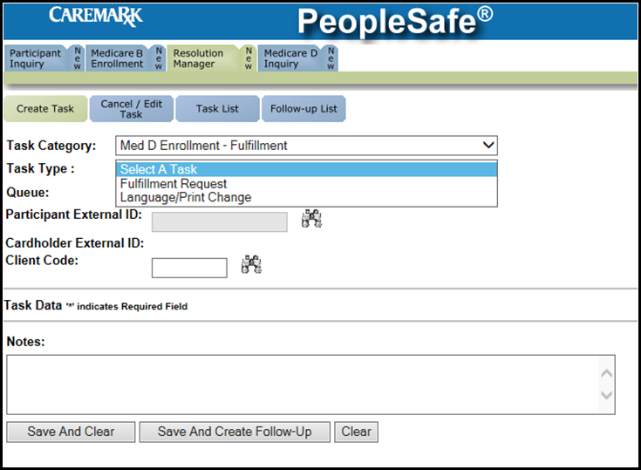
Figure D

Top of the Document

Required Fields within the RM Task/Additional Information

Status Updates/ Resolution of RM Tasks
Alternate Format (i.e. Language/Print Change) Requests
Verbal Attestation
Contract and PBP ID
Address Change
State Field - next to Date of Birth

Use as needed:
Status Updates/ Resolution of RM Tasks | Once a task has been submitted, CCRs must review the Medicare D Inquiry Tab in PeopleSafe to determine resolution (i.e. status) of tasks.  Status updates/resolution will NOT display within the task itself.
Alternate Format (i.e. Language/Print Change) Requests | Refer to Med D - Fulfillment Request for RM Task instructions.
Verbal Attestation  This is only applicable for POA and Authorized Representative Attestations | Verbal attestation is a required field for all Enrollment-related RM Task Types.  This field is referring to the standard verbal attestation provided by a power of attorney or authorized representative, which is providing any information related to the beneficiary. This attestation is required for anyone, even if they do not have a Power of Attorney or Authorized Representative on File.  Refer to MED D - Appointed Representative Form (AOR) or Power of Attorney (POA) and MED D - Obtaining a Verbal Attestation from an Authorized Representative.  CCR Process Note: If caller verbally attests to being the legal representative, the CCR must state the following disclaimer, select Yes in the Verbal Attestation field of the RM Task, and document in RM Task Notes the Name, Address, and Phone # of the caller:  - Do you attest that you have the authority to speak on behalf of <beneficiary name> under state law, and that proof of such authorization is available upon request by CMS?  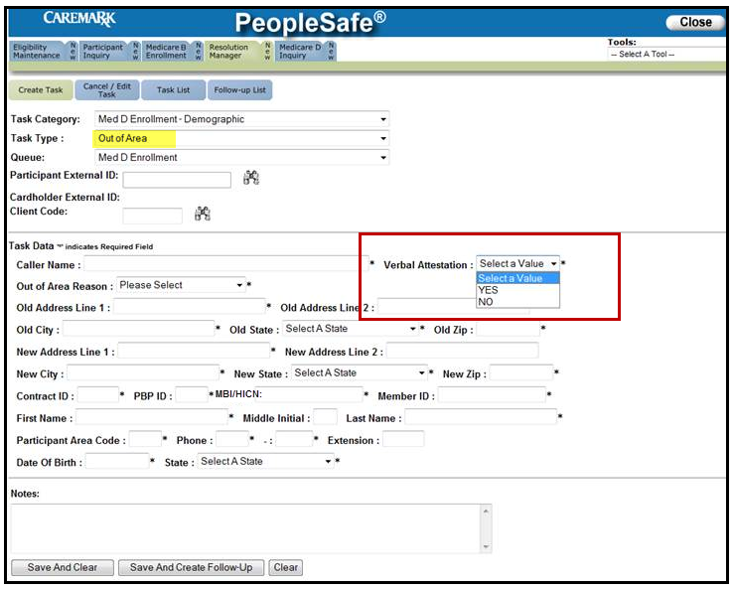
Contract and PBP ID | When a beneficiary is not found eligible in PeopleSafe, then the contract ID or PBP ID does not auto populate in RM Task.  - This is a required field so CCRs must input the correct information within the RM Task.  Note: Contract ID should only be S2893 (NEJE) or S5601 (SSI). PBP ID must be 3-digits.  Refer to the following for NEJE PBP IDs:  - 001 for Value Plus  - 003 for Premier  - 801 for EGWP  Note: The entire contract number and entire PBP needs to be entered when submitting RM Tasks.  CCRs should obtain this information from Medicare D Inquiry Tab - Plan Details screen while creating the RM Task.  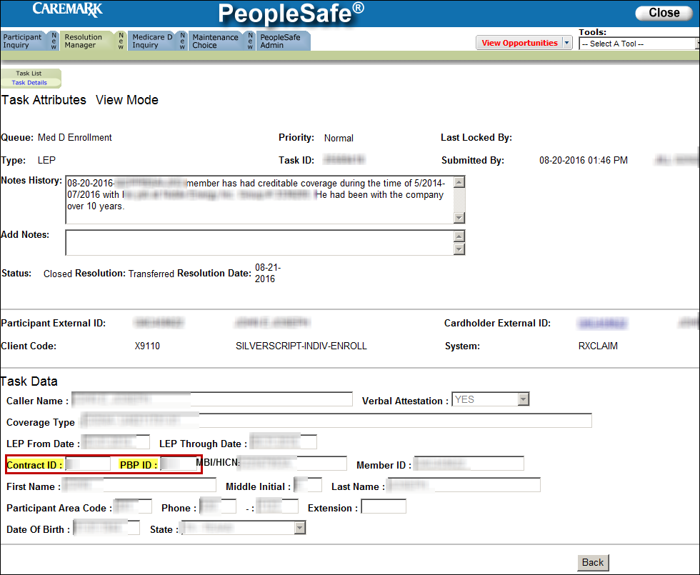  Note: CCRs must ensure the cursor is at the beginning of the field to input text. If unable to enter text, hit backspace multiple times until the text can be entered.  Medicare D Inquiry Tab - Plan Details Screen:  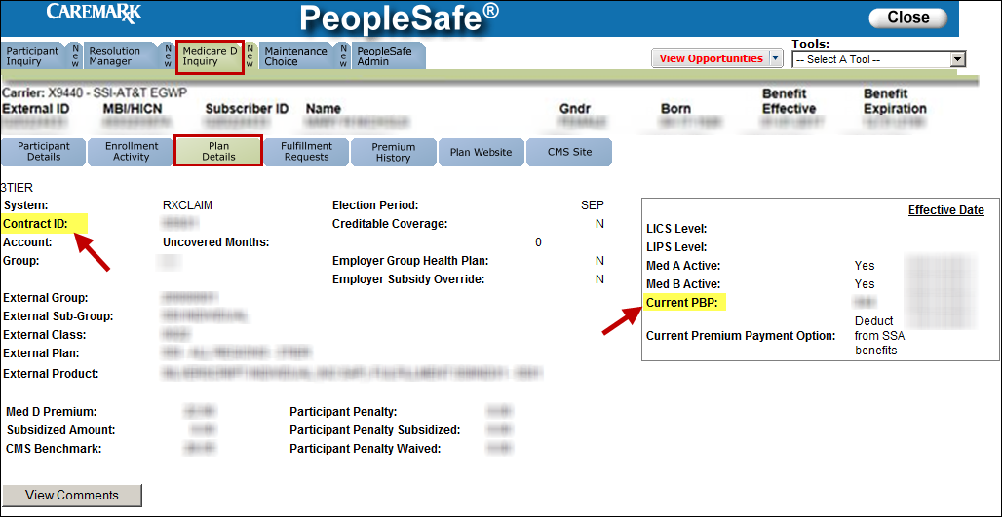  If unable to find Contract ID and PBP ID in PeopleSafe, refer to FAZAL:  Note: This process is for NEJE only.  - Search beneficiary by MBI and click Submit.  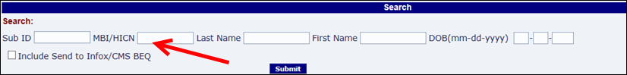  Result: The following screen displays:  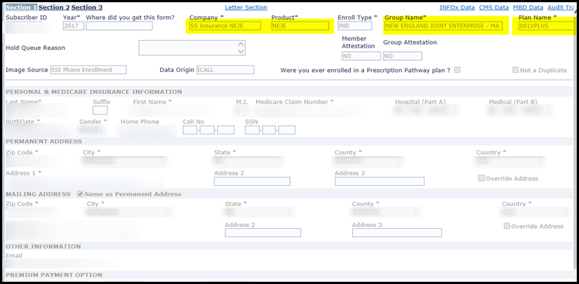  - Company and Product fields reference the Contract ID:  - NEJE = S2893  - The first three numbers in Plan Name field is the PBP ID.  - Example: Plan Name = 001 VPLUS, so PBP ID is 001.
Address Change | For Address Change Tasks Only:  - The Address Change box needs to be selected to fit the correct situation:  - Mailing Address  - For temporary address changes (less than 12 months), ALWAYS select Mailing Address  - Permanent & Mailing: Should be used when permanent and mailing address are the same address.  Note: If Permanent Address change results in an out of area move, proceed to OOA Involuntary to submit an OOA RM Task. Do not submit an Address Change RM task.  - Permanent Address  CCRs must manually check Old and New Address fields in RM Task to ensure the correct addresses are being documented.  Note: If the beneficiary is updating multiple addresses (i.e. permanent and mailing address that are different), CCRs should submit Mailing Address RM Task AND Permanent Address RM Task separately.  - Include confirmation of the address type (Mailing Only, Permanent Only) in the RM Task note.  - Phone number needs to be added to task and documented in the task notes if this number is different from what is on file.  - If it is not updated, CCR must note why they were not able to update the phone number on file.  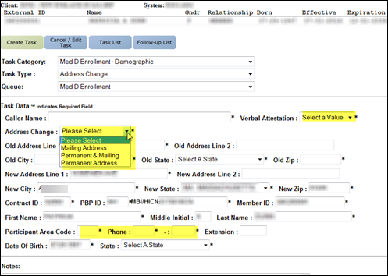
State Field - next to Date of Birth | CCRs must input beneficiary’s residential state within the State field. DO NOT ask beneficiary what state they were born in/or state of birth.  

Top of the Document

Task Category: Med D Enrollment - Demographic

Address Change
Out of Area
Name Change

Use as needed:
Topics | Actions | RM Task
Address Change  Refer to MED D - Address Changes and Out of Area (OOA) work instructions.  Note: Always use the RxEnroll Care link located on the Medicare D Inquiry Tab of PeopleSafe unless there is a system issue.  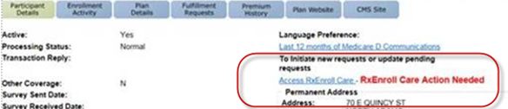 | Permanent Address update is needed. | If the Permanent address is…
 | Permanent Address update is needed. | If Region… | Then…
 | Permanent Address update is needed. | Same state and/or region  OR  Different state but same region | Task Category: Med D Enrollment - Demographic  Task Type: Address Change  Queue: Med D Enrollment Task  Notes:  - Beneficiary confirmed that they permanently live at <insert complete permanent address>  - <Include old permanent address>  - Include phone number  - Direct Enrollment Team to complete additional research
 | Permanent Address update is needed. | In a different Region | Task Category: Med D Enrollment - Demographic  Task Type: Out of Area  Queue: Med D Enrollment Task  Notes:  - Per beneficiary updated profile with new permanent address (include complete new address) and mailing address  - New address is out of the current service area (Region).  - <Include old address>  - Include phone number  - Informed the beneficiary that they will be involuntarily disenrolled at the end of the month.  - Transferred to enrollment specialists for new enrollment  - Confirmed beneficiary out of area.
 | Permanent Address update is needed. | No Residential Address, PO Box is a valid address | Task Category: Med D Enrollment - Demographic  Task Type: Address Change  Queue: Med D Enrollment Task  Notes: Document in the notes:  - Note must include that beneficiary has no residential address and ONLY has a P.O. Box address or verbally verified they live in the Service Area where the P.O. Box is located.  - Beneficiary’s Permanent (Home or Primary) Address was changed on MM/DD/YYYY from <OLD Address> to <NEW Address> as requested by <caller>.  Exception: NEJE beneficiaries may have a PO Box for mailing address but not permanent address.
 | Moved to an area where SilverScript and/or Blue MedicareRx (NEJE) is NOT provided (i.e. Canada).  Refer to MED D - Address Changes and Out of Area (OOA). | Task Category: Med D Enrollment - Demographic  Task Type: Out of Area  Queue: Med D Enrollment Task  Notes: Include the following notations:  - Per beneficiary updated profile with new address (include old and new address)  - New address is outside of the country.
 | Incarcerated  Refer to MED D - Address Changes and Out of Area (OOA). | Task Category: Med D Enrollment - Demographic  Task Type: Out of Area  Queue: Med D Enrollment Task  Notes: Include the following notations:  - Who confirmed the incarceration (if provided by someone other than the beneficiary, obtain contact information including:  - Name  - Address  - Phone #  - Start date of the incarceration (if provided by the caller) (MM/YY)  - End date of the incarceration (if provided by the caller) (MM/YY)  - Direct Enrollment Team to complete additional research to confirm the disenrollment due to incarceration.
Out of Area  Response to OOA Letter / Undeliverable Mail  Refer to MED D - Address Changes and Out of Area (OOA) work instructions.  Note: Always use the RxEnroll Care link located on the Medicare D Inquiry Tab of PeopleSafe unless there is a system issue. | The same permanent address and no changes need to be made | Task Category: Med D Enrollment - Demographic  Task Type: Out of Area  Queue: Med D Enrollment Task  Notes:  - Beneficiary confirmed that they permanently live at <insert complete permanent address>  - Include complete (Street number, Street Name, City, State and Zip Code) OLD and NEW addresses  - Include complete Contact number (Area Code) 7 digit phone number  - Direct Enrollment Team to resolve OOA workflow in Exception Management Application (EMA) as Confirmed in Area.
 | Permanent Address update is needed. | If the Permanent address is…
 | Permanent Address update is needed. | If… | Then…
 | Permanent Address update is needed. | Same state and/or region  OR  Different state but same region | Task Category: Med D Enrollment - Demographic  Task Type: Out of Area  Queue: Med D Enrollment Task  Notes:  - Beneficiary confirmed that they permanently live at <insert complete permanent address>  - <Include old permanent address>  - Include phone number  - Direct Enrollment Team to complete additional research before resolving the OOA workflow in Exception Management Application (EMA) as Confirmed In Service Area.
 | Permanent Address update is needed. | In a different Region | Task Category: Med D Enrollment - Demographic  Task Type: Out of Area  Queue: Med D Enrollment Task  Notes: Per beneficiary updated profile with new permanent address (include complete new address) and mailing address  - New address is out of the current service area (Region).  - <Include old address>  - Include phone number  - Informed the beneficiary that they will be involuntarily disenrolled at the end of the month.  - Transferred to enrollment specialists
 | A complete mailing address update only is needed | Task Category: Med D Enrollment - Demographic  Task Type: Address Change  Queue: Med D Enrollment Task  Notes:  - Beneficiary confirmed that they permanently live at <insert complete permanent address>  - Beneficiary provided new mailing address of <insert complete mailing address>  - <Include old mailing address>  - Include phone number  - Direct Enrollment Team to resolve OOA workflow in Exception Management Application (EMA) as Confirmed In Area.
 | Incarcerated | Task Category: Med D Enrollment - Demographic  Task Type: Out of Area  Queue: Med D Enrollment Task  Notes:  - Per <insert name of person who confirmed> beneficiary is currently incarcerated.  - Indicate the approximate start date of incarceration.  - Indicate the facility the beneficiary is currently incarcerated in.  - Direct Enrollment Team to complete additional research before resolving the OOA workflow in Exception Management Application (EMA) as appropriate.
 | Moved to an area where SilverScript and/or Blue MedicareRx (NEJE) is NOT provided (i.e. Canada). | Task Category: Med D Enrollment - Demographic  Task Type: Out of Area  Queue: Med D Enrollment Task  Notes:  - Per beneficiary updated profile with new permanent and mailing address (include complete new address)  - New address is out of the current service area (Region).  - <Include old permanent and mailing address>  - Direct Enrollment Team to resolve OOA workflow in Exception Management Application (EMA) as appropriate.
Name/DOB/MBI Change | If the beneficiary’s Name or DOB or MBI is incorrect in MARX, the beneficiary must contact Social Security at 800-772-1213 in order to have that corrected. Do NOT submit an RM Task.  If the beneficiary’s Name or DOB or MBI is correct in MARX but incorrect in PeopleSafe, then the CCR will submit the RM Task. | Task Category: Med D Enrollment - Demographic  Task Type: Name Change  Queue: Med D Enrollment Task  Notes: Document detailed information in the notes (name changes, DOB changes, MBI changes).  - Include confirmation of name change in MARx

Top of the Document

Task Category: Med D Enrollment - Enrollment

Cancellation of Enrollment
Effective Date Change
Late Enrollment Penalty
Low Income Subsidy
Missing Pre-Enrollment Information
Opt Hold/ Group Attestation
TRC 127
SPAP
Enrollment Not Found
Enrollment/Eligibility Discrepancy

Use as needed:
Topics | Actions | RM Task
Cancellation of Enrollment  Refer to MED D - Cancellation of Enrollment for appropriate process.  Confirm effective date.  Example:  - If beneficiary calls in January 2 and effective date is February 1, this is a cancellation of enrollment  - If beneficiary calls in January 2 and effective date is January 1, this is a disenrollment. | Cancel Enrollment | Task Category: Med D Enrollment - Enrollment  Task Type: Cancellation of Enrollment  Queue: Med D Enrollment Task  Task Data: The CCR must include the following pieces of information:  - Caller Name,  - If POA is not on file, authorized representative may verbally attest to being a legal representative, the CCR must document the following information  - Beneficiary’s first and last name in addition to caller’s first and last name, callers address and callers’ phone #.  - Continue to assist in submitting a request for cancellation of enrollment and document in PeopleSafe  - VERBAL ATTESTATION: (Yes/No)  - If caller is attesting to authority to speak on behalf of the beneficiary, select yes  - If caller is not authorized to speak on behalf of the beneficiary, do not submit a request  - Enrollment Effective Date  - Notes: “<Todays Date> <Caller’s Name> is requesting to cancel their enrollment request effective xx/xx/xxxx”  - Document in call notes the beneficiary’s first and last name in addition to caller’s first and last name, callers address and callers’ phone #.
 | Cancel Enrollment with Opt Out Language | Task Category: Med D Enrollment - Enrollment  Task Type: Cancellation of Enrollment  Queue: Med D Enrollment Task  Task Data: The CCR must include the following pieces of information:  - Caller Name,  - If caller is legal representative, document in notes the beneficiary’s first and last name in addition to caller’s first and last name, callers address and callers’ phone #.  - VERBAL ATTESTATION: (Yes/No)  - If caller is attesting to authority to speak on behalf of the beneficiary, select yes  - If caller is not authorized to speak on behalf of the beneficiary, do not submit a request  - Enrollment Effective Date  - Notes: “<Todays Date> <Caller’s Name> is requesting to cancel their enrollment request effective xx/xx/xxxx. Beneficiary understands the consequences of choosing to opt out of the auto-enrollment process”  - Caller’s address must be provided if the caller is not the beneficiary
 | Cancellation of Enrollment Due to Outbound Enrollment Verification (OEV) Letter | Task Category: Med D Enrollment - Enrollment  Task Type: Cancellation of Enrollment OEV  Queue: Med D Enrollment Task  Notes: Document detailed information in the task note.  If beneficiary calls in response to an OEV letter and decides to cancel the enrollment, the CCR should notate reason for cancellation (DOEVL Letter).  Example: Beneficiary’s enrollment was effective 05/01/2015 with an app date of 04/30/2015. The OEV letter gives the beneficiary until 05/14/2015 to CANCEL the enrollment.
Effective Date Change  Refer to MED D – Request to Change Enrollment Effective Date. | Make NO guarantees that the effective date will be changed | Task Category: Med D Enrollment - Enrollment  Task Type: Effective Date Change  Queue: Med D Enrollment Task  Notes: Include the following:  - Document the date the beneficiary is requesting as a new effective date.  - Include the reason for the request
Late Enrollment Penalty  Refer to the MED D – Late Enrollment Penalty Attestation and Appeals work instructions.  Note: Always use the RxEnroll Care link located on the Medicare D Inquiry Tab of PeopleSafe unless there is a system issue or you have not been trained in RxEnroll Care. | Attest to Coverage | Task Category: Med D Enrollment - Enrollment  Task Type: Late Enrollment Penalty  Queue: Med D Enrollment Task  Notes: Document details in the task note to include:  - The source of the beneficiary’s creditable prescription drug coverage (i.e. employer group, SPAP, Tricare/VA, etc.)  - Include the beginning month/year, ending month/year of the creditable coverage.  - Month & Year are required fields  - Notate if the beneficiary never had creditable coverage.
 | Discrepancies in covered or uncovered months | Task Category: Med D Enrollment - Enrollment  Task Type: Late Enrollment Penalty  Queue: Med D Enrollment Task  Notes: Document details in the task note to include:  - The source of the beneficiary’s creditable prescription drug coverage (i.e. employer group, SPAP, Tricare/VA, etc.)  - Include the beginning month/year, ending month/year of the creditable coverage.  - Month & Year are required fields
 | LEP Reconsideration Packet  Validate the beneficiary’s address | Task Category: Med D Enrollment - Enrollment  Task Type: Late Enrollment Penalty  Queue: Med D Enrollment Task  Notes: Document that you have validated the beneficiary’s address  - Ensure the request for a reconsideration packet is clearly stated in the task note.
Low Income Subsidy  Refer to:MED D - Low Income Subsidy (LIS) Informational Overview  OR  MED D - Blue MedicareRx (NEJE) Low Income Subsidy (LIS) Dispute & Best Available Evidence (BAE) - Process for Urgent Need of Medication  MED D - Specialized Member Services Team (SMST) - Low Income Subsidy (LIS) Dispute & Best Available Evidence (BAE) - Process for Urgent Need of Medication  ALWAYS CHECK MARx for beneficiary’s LIS Status. If no access to MARx warm transfer to Senior Team with access. | Is Displaying and the beneficiary states it is NOT correct OR NOT displaying | Task Category: Med D Enrollment - Enrollment  Task Type: Low Income Subsidy  Queue: Med D Enrollment Task  Notes:  - Indicate SSI or NEJE  - Beneficiary has 3 day supply or less of medication  - Beneficiary accepted or denied temporary LIS  - Document one of the following:  - Beneficiary has evidence  - Beneficiary does not have evidence  - Beneficiary is stating they have a different LIS level.  - Beneficiary has been informed to submit BAE documentation or has been advised CMS will conduct a review on if they qualify for subsidy.
 | LIS Update - PeopleSafe to Match MARx | Task Category: Med D Enrollment - Enrollment  Task Type: Low Income Subsidy  Queue: Med D Enrollment Task  Notes: Document all details in the task note. Verified in MARx the correct LIS level and the beneficiary has provided the correct amount.
Missing Pre-Enrollment Information  Refer to MED D - Incomplete Enrollments (ICE) or Enrollments with Missing Information work instructions.  Note: If beneficiary is not in PeopleSafe, ensure that ALL missing information is obtained and updated within FAZAL. Ensure that ALL missing information is obtained. | Responding to a letter or phone call requesting more information to process enrollment. | Task Category: Med D Enrollment - Enrollment  Task Type: Missing Pre-Enrollment RFI  Queue: Med D Enrollment Task  Notes: Document detailed information in the task note to include:  - Submitter’s name  - Beneficiary name  - “G” Number  - Invalid MBI  - Valid MBI  - Invalid DOB  - Valid DOB  - Phone number  OR  - If applicable, reason for SEP and SEP date.  - Example: For losing Employer coverage - beneficiary must also provide the date they lost or will lose employer coverage.  - Primary Physical Address  - Mailing Address  The following details MUST be included:  - Caller Status (Beneficiary, POA, Legal Representative and/or SHIP Counselor)  - If POA, LR or SHIP Counselor the CCR MUST include the following:  - FULL NAME of POA, LR or SHIP Counselor  - Mailing Address  - Telephone number  CCR Process Note: If the beneficiary is not yet loaded in FACETS, the following identifiers MUST be included in the RM Task:  - Full Name  - DOB  - MBI  - Address  - Telephone number
 | No Residential Address, PO Box is address - Beneficiary responding to a letter or phone call requesting more information to process enrollment | Task Category: Med D Enrollment - Enrollment  Task Type: Missing Pre-Enrollment RFI  Queue: Med D Enrollment Task  Notes: Document detailed information in the task note to include:  - Beneficiary verbally attests they live in same area where the P.O. Box is.  CCR Process Note: If the beneficiary is not yet loaded in FACETS, the following identifiers MUST be included in the RM Task:  - Full Name  - DOB  - MBI  - Address  - Telephone number
Opt Hold/ Group Attestation  Refer to MED D - EGWP Opt Hold Release Process in FAZAL (SMST Only) work instructions  Confirm the beneficiary is not on hold for TRC 127 prior to submission of Attestation in Fazal. | Attests | Task Category: Med D Enrollment - Enrollment  Task Type: Opt Hold/Group Attestation  Queue: Med D Enrollment Task  Notes: Include the following: The Beneficiary DOES want the Plan and attests that they want the enrollment released to CMS before the 21-day hold period ends.
 | Does Not Attest | Task Category: Med D Enrollment - Enrollment  Task Type: Opt Hold/Group Attestation  Queue: Med D Enrollment Task  Notes: Include the following: The Beneficiary does NOT want the Plan, and they want to Opt Out of the plan before the 21-day hold period ends.
TRC 127  Refer to:  MED D - Blue MedicareRx (NEJE) - Enrollee Attestation for Future Enrollment (TRC 127 Attestation)  MED D - Specialized Member Services Team (SMST) - Enrollee Attestation for Future Enrollment (TRC 127 Attestation)  Note: Always use the RxEnroll Care link located on the Medicare D Inquiry Tab of PeopleSafe unless there is a system issue or you have not been trained in RxEnroll Care. | If beneficiary wants to continue with the enrollment | Task Category: Med D Enrollment - Enrollment  Task Type: TRC 127  Queue: Med D Enrollment Task  The CCR MUST include the following pieces of information:  - Caller’s Name  - Deadline Date  - <Caller’s Name> contacted Customer Care < (if not the beneficiary, attestation of POA MUST be included with address and phone number of caller) on behalf the beneficiary> before deadline of <insert deadline date here> and they intend to enroll into the requested <SilverScript or Blue MedicareRx (NEJE)> plan. The beneficiary understands the consequences of continuing their enrollment into <SilverScript or Blue MedicareRx (NEJE)>.  - (If applicable) The beneficiary’s employer group, retiree plan or union group is discontinuing their prescription drug coverage.
 | If beneficiary does not want to continue with enrollment (Denial) | Task Category: Med D Enrollment - Enrollment  Task Type: TRC 127  Queue: Med D Enrollment Task  The CCR MUST include the following pieces of information:  - Caller’s Name  - Deadline Date  <Caller’s Name> contacted Customer Care < (if not the beneficiary, attestation of POA MUST be included with address and phone number of caller) on behalf the beneficiary> before deadline of <insert deadline date here> and “Beneficiary has chosen to decline enrollment into SSIC Part D Plan.
SPAP  Refer to MED D - Handling State Pharmaceutical Assistance Program Calls | The CCR MUST review the appropriate CIF and all related work instructions prior to sending this RM Task. | Task Category: Med D Enrollment - Enrollment  Task Type: SPAP - State pharmaceutical Assistance Program  Queue: Med D Enrollment Task  Notes: Include the following:  - <Client Code: Name of SPAP>  - Detailed notes regarding the beneficiary’s SPAP inquiry
Enrollment Not Found  Refer to  - MED D - SilverScript - Real Time Resolution of Eligibility.  - MED D - Blue MedicareRx (NEJE) - Real Time Resolution of Eligibility | - Check FAZAL and Marx if no enrollment and the enrollee is not in our plan in Marx.  - Offer to take a new enrollment if there is a valid election period.  - Refer to MED D - Election Periods for Enrollment and Disenrollment (AEP, IEP, SEP)  CCR Process Note: If enrollment is for an EGWP client, have the enrollee contact their benefit coordinator. | Task Category: Med D Enrollment - Enrollment  Task Type: Enrollment Not Found  Queue: Med D Enrollment Task  Notes: Document that no enrollment was found in FAZAL and Marx.  Include any additional information provided by the beneficiary related to their call.
Enrollment/Eligibility Discrepancy | Escalated Enrollment Research  **This should only be used when the enrollment issue is not defined anywhere else.  CCR Process Note:  - This route should be used when the beneficiary is disputing which plan they are currently enrolled in  - Even if all systems and the enrollment portal show the beneficiary in the same plan (i.e. Choice and the beneficiary is stating that they enrolled in Plus), the CCR will route in order to have the enrollment researched including having the enrollment call pulled.  - The CCR should advise the beneficiary about disenrollment. If beneficiary requests disenrollment, educate beneficiary on ALL options to disenroll and offer to send the disenrollment form.  - Refer to  - MED D - Voluntary Disenrollment (SMST Only)  - MED D - Blue MedicareRx (NEJE) Voluntary Disenrollment | Task Category: Med D Enrollment - Enrollment  Task Type: Enrollment/Eligibility Discrepancy  Queue: Med D Enrollment Task  Notes: Document detailed information in the task note, be clear and concise, and include the beneficiary’s phone number.
Enrollment/Eligibility Discrepancy | Beneficiary’s application is on hold due to a past due amount owed and the amount has been paid.  CCR Notes:  - Check DTROU letter in OneClick for reply by date that beneficiary has to pay the balance  - If beneficiary is calling to pay prior to or on the reply by date, send RM task  If beneficiary is calling to pay after the reply by date, info the beneficiary application has been denied due to non-response. A new enrollment will need to be submitted to be enrolled in the plan. | Task Category: Med D Enrollment - Enrollment  Task Type: Enrollment/Eligibility Discrepancy  Queue: Med D Enrollment Task  Notes: CCR needs to include the amount paid on date, along with any other pertinent information.  CCR Note: Document the amount paid on date, along with any other pertinent information in PeopleSafe

Top of the Document

Task Category: Med D Enrollment - Disenrollment

DO NOT USE THESE RM TASKS FOR NEW DISENROLLMENT REQUESTS.

Cancellation of Voluntary Disenrollment
Missing Information for Voluntary Disenrollment
Mistaken Disenrollment

Use as needed:
Topics | Actions | RM Task
Cancellation of Voluntary Disenrollment  Refer to:  MED D - Blue MedicareRx (NEJE) - Cancellation of Voluntary Disenrollment  MED D - Specialized Member Services Team (SMST) - Cancellation of Voluntary Disenrollment |  | Task Category: Med D Enrollment - Disenrollment  Task Type: Cancellation of Voluntary Disenrollment  Queue: Med D Enrollment Task  Notes: Document detailed information in the task note.  CCR Process Note: CCR will submit RM Task and if needed the beneficiary will receive a call back within <96> hours or written confirmation of completion will be sent.
Missing Information for Voluntary Disenrollment  Refer to:  MED D - Voluntary Disenrollment (SMST Only)  MED D - Blue MedicareRx (NEJE) Voluntary Disenrollment | This task type can also be used if beneficiary is requesting a duplicate copy of the confirmation letter of disenrollment. CCRs must indicate this request in RM Task Notes. | Task Category: Med D Enrollment - Disenrollment  Task Type: Missing Information for Voluntary Disenrollment  Queue: Med D Enrollment Task  Notes: Document all disenrollment information (Election Period, and Attestation to request disenrollment) in the task note.
Mistaken Disenrollment  Refer to MARx and/or the Medicare D Inquiry Tab in PeopleSafe (Disenrollment Reason). | If... | And… | RM Task…
 | Loss of A/B/D  Refer to:  MED D - Blue MedicareRx (NEJE) - Mistaken Disenrollment of a Beneficiary  MED D - Specialized Member Services Team (SMST) - Mistaken Disenrollment of a Beneficiary | Termed in MARx | Task Category: Med D Enrollment - Disenrollment  Task Type: Mistaken Disenrollment  Queue: Med D Enrollment Task  Notes: Beneficiary called to advise they were involuntarily disenrolled due to <Incorrect Date of Death reported or Loss of Part A, B, and D>. Beneficiary can be reached at <current phone number> at <best time to contact>. Beneficiary’s current complete address is <address (include city, state, and zip code)>. Beneficiary has <less/more> than 3 days medication on hand. Beneficiary was informed to continue to use plan services. Beneficiary was advised to contact SSA. Eligibility was verified in MARx.
 |  | Reinstated in MARx | Task Category: Med D Enrollment - Disenrollment  Task Type: Mistaken Disenrollment  Queue: Med D Enrollment Task  Notes: Beneficiary called to advise they were involuntarily disenrolled due to <Incorrect Date of Death reported or Loss of Part A, B, and D>. Beneficiary can be reached at <current phone number> at <best time to contact>. Beneficiary’s current complete address is <address (include city, state, and zip code)>. Beneficiary has <less/more> than 3 days medication on hand. Eligibility was verified in MARx.
 | Erroneous Death  Refer to:  MED D - Blue MedicareRx (NEJE) - Mistaken Disenrollment of a Beneficiary  MED D - Specialized Member Services Team (SMST) - Mistaken Disenrollment of a Beneficiary | Termed in MARx | Task Category: Med D Enrollment - Disenrollment  Task Type: Mistaken Disenrollment  Queue: Med D Enrollment Task  Notes: Beneficiary called to advise they were involuntarily disenrolled due to <Incorrect Date of Death reported or Loss of Part A, B, and D>. Beneficiary can be reached at <current phone number> at <best time to contact>. Beneficiary’s current complete address is <address (include city, state, and zip code)>. Beneficiary has <less/more> than 3 days medication on hand. Beneficiary was informed to continue to use plan services. Beneficiary was advised to contact SSA. Eligibility was verified in MARx.
 |  | Reinstated in MARx | Task Category: Med D Enrollment - Disenrollment  Task Type: Mistaken Disenrollment  Queue: Med D Enrollment Task  Notes: Beneficiary called to advise they were involuntarily disenrolled due to <Incorrect Date of Death reported or Loss of Part A, B, and D>. Beneficiary can be reached at <current phone number> at <best time to contact>. Beneficiary’s current complete address is<address (include city, state, and zip code)>. Beneficiary has <less/more> than 3 days medication on hand. Eligibility was verified in MARx.
 | Retroactive Disenrollment  Refer to:  MED D - Voluntary Disenrollment (SMST Only)  MED D - Blue MedicareRx (NEJE) Voluntary Disenrollment | N/A | Task Category: Med D Enrollment - Disenrollment  Task Type: Missing Information for Voluntary Disenrollment  Queue: Med D Enrollment Task  Notes: Document detailed information in the RM task note and be as detailed as possible so the request is clear.  - Date (required; alleged enrollment/disenrollment) Method by which beneficiary requested disenrollment  Example: Medicare website, calling 800-Medicare (include confirmation number from 800-Medicare), written request submitted to the plan  - Reason on why beneficiary is disputing disenrollment effective date.
 | New MCO  Refer to:  MED D - Blue MedicareRx (NEJE) - Mistaken Disenrollment of a Beneficiary  MED D - Specialized Member Services Team (SMST) - Mistaken Disenrollment of a Beneficiary | Other plan is not cancelled | Refer beneficiary to Medicare.
 |  | If other plan cancelled, and beneficiary not reinstated into SilverScript/Blue MedicareRx | Task Category: Med D Enrollment - Disenrollment  Task Type: Mistaken Disenrollment  Queue: Med D Enrollment Task  Notes: Beneficiary called to advise they were involuntarily disenrolled due to enrolling into another plan and cancelling that plan. Beneficiary can be reached at <current phone number> at <best time to contact>. Beneficiary’s current complete address is<address, including city, state, and zip code>. Beneficiary was informed to continue to use plan services. Beneficiary has <less/more> than 3 days medication on hand. Eligibility was verified in <MARx>.
 | OOA | N/A | Task Category: Med D Enrollment - Disenrollment  Task Type: Mistaken Disenrollment  Queue: Med D Enrollment Task  Notes: Beneficiary has been disenrolled for OOA.  Beneficiary has no coverage and there is no enrollment pending in Fazal to reinstate the beneficiary with no lapse in coverage. Beneficiary has contacted the plan to update their address and was deemed OOA. Beneficiary has now contacted the plan multiple times regarding their address change and/or OOA/Disenrollment letters received. Beneficiary can be reached at <current phone number> at <best time to contact>. Beneficiary’s current complete address is<address, including city, state, and zip code>. Beneficiary was informed to continue to use plan services and that someone would contact them within 24 – 72 hours. Please review for plan error(s) for reinstatement.
 | NOT provided all the disenrollment options when requesting to disenroll. | N/A | Task Category: Med D Enrollment - Disenrollment  Task Type: Mistaken Disenrollment  Queue: Med D Enrollment Task  Notes: Beneficiary requested to be disenrolled from the plan. Beneficiary not provided all disenrollment options. Beneficiary requesting to be retro disenrolled. Beneficiary can be reached at <current phone number> at <best time to contact>. Beneficiary’s current complete address is<address, including city, state, and zip code>. Please review for plan error(s) for disenrollment.

Top of the Document

Task Category: Med D Enrollment - Fulfillment
DO NOT USE THESE RM TASKS FOR NEW DISENROLLMENT REQUESTS.

Fulfillment Request
Language/Print Change

Note: This request is no longer routed under this task category. See MED D - Fulfillment Request for additional details.

Use as needed:
Topics | Actions | RM Task
Fulfillment Request | Determine what the request is.  Refer to MED D - Fulfillment Request | Task Category: Med D Enrollment - Fulfillment  Task Type: Fulfillment Request  Queue: Med D Enrollment Task  Notes: Include detailed notes:  - Who is placing the request (Example: Beneficiary, POA, AOR or legal representative)  - Item being requested for the current or future benefit year:  - Examples:  - Annual Notice of Change (ANOC)/EOC packet  - Packet includes ANOC, EOB and LIS Rider (if applicable)  - Welcome Packet
Language/Print Change | Refer to MED D - Fulfillment Request.  DO NOT SEND AN RM TASK to Med D Enrollment for a language/print change.

Top of the Document

Turn Around Times

Use as needed:
Task Type | TAT Times  (calendar days) | Phone Contact | Written Communication  (TAT = 15 calendar days)
Address Change | Up to 7 days | No (unless out of region) | No (unless out of region)
Cancellation of Enrollment | Up to 7 days | No | Yes
Cancellation of Enrollment - OEV | Up to 7 days | No | Yes
Cancellation of Voluntary Disenrollment | Up to 7 days | No | Yes
Effective Date Change | Up to 7 days | No | Yes
Enrollment Not Found | Up to 7 days | Yes | Yes
Enrollment/Eligibility Discrepancy | Up to 7 days | Yes | No
Language/Print Change | 20 days | No | Yes (Typically a replacement mailing is requested with print change)
LEP - Late Enrollment Penalty | 30+ days | No (Unless incomplete) | Yes (Unless received before penalty is assessed and complete attestation)
LEP Reconsideration Packet | Up to 7 days | No | Yes
Missing Information for Voluntary Disenrollment | Up to 7 days | Yes | Yes
Missing Pre-enrollment Information - RFI | Up to 7 days | Yes | Yes
Mistaken Disenrollment | Up to 7 days | Yes | Yes
Name Change | Up to 7 days | No (unless it does not match CMS records, beneficiary contacted to contact SSA) | Yes (If name changes and matches CMS records)
Opt Hold/Group Attestation | Up to 7 days | No | Yes
Out of Area | Up to 7 days | Yes | Yes (If address confirmed out of region)
SPAP - State Pharmaceutical Assistance Program | Up to 7 days | No | No
TRC 127 | Up to 7 days | No (Unless Incomplete) | Yes
LIS - Low Income Subsidy | Up to 4 days | Yes (If change occurs as courtesy) | Yes (When TRC confirmation received)
Fulfillment Request | Up to 4 days | No | Yes

Top of the Document

Related Documents
Parent SOP: CALL-0048: Medicare Part D Customer Care Call Center Requirements-CVS Caremark Part D Services, L.L.C.
Abbreviations/Definitions: Abbreviations / Definitions

Top of the Document
Not To Be Reproduced Or Disclosed to Others Without Prior Written Approval
ELECTRONIC DATA = OFFICIAL VERSION - PAPER COPY = INFORMATIONAL ONLY

